**Instructions:**Replace **[bracketed red text]** with the requested information or screen capture.  
Replace **bracketed red text with black text**.  
**PLEASE do not include full page, full window screen shot images**, or full screen shots that have been reduced in size.   
Use a snippet tool to capture parts of the screen and insert those images into the template.  
**Do not remove tags from this template. An example of a tag is [C01]. All fields are required.***Please do not alter template formatting or delete parts of this template.*

Part A - Student Information:   
 **1. Student Name: Abel Marin**

**2. What day and date did you start this assignment? Thursday March 12, 2020**

Go back to the instructions and continue with Part B.Part B –CMS Shared Webhost Information:

Enter your shared web host Drupal 8 site information below:

1. **Assignment Website In-Directory Name:** **[**assignment09**]**
2. **WEBSITE Admin Username:** **[**ajmarin**]**
3. **WEBSITE Admin Password:** **[**&L4$IWeZ#1**]**
4. **Assignment Website URL:** **[**http://abelm.sgedu.site/assignment09**]**
5. Go back to the instructions and continue with Part C.

-OR- if you used Pantheon (PA) fill out the information below:

1. **Pantheon Account Info:** 
   * **Pantheon Account Email: [Your Pantheon Account Email]**
2. **Pantheon Site Name:** **[SITE NAME]**
3. **WEBSITE Admin Username:** **[ADMIN USERNAME]**
4. **WEBSITE Admin Password:** **[ADMIN PASSWORD]**
5. **Pantheon site URL: [**Your Pantheon CMS Site URL**]**

Go back to the instructions and continue with Part C.

Part C – Media and Media Library

1. SCREEN CAPTURE – Backend screen capture of the media uploaded to the site  
   Admin toolbar > Media, listing all the media files you added to the system[A screenshot of a computer screen

   Description automatically generatedA screenshot of a computer screen

   Description automatically generated] [C01]
2. SCREEN CAPTURE – Backend Modifications to the WYSIWYG  
   Admin toolbar > CONFIGURAITON > CONTENT AUTHORING, Text formats and editors   
   SELECT basic HTML, CONFIGURATION OPTION  
   Screen capture with the TOOLBAR CONFIGURATION (Active toolbar) buttons visible

] [C02]

1. SCREEN CAPTURE – Backend Modifications to the WYSIWYG  
   Admin toolbar > CONFIGURAITON > CONTENT AUTHORING, Text formats and editors   
   SELECT full HTML, CONFIGURATION OPTION  
   Screen capture with the TOOLBAR CONFIGURATION (Active toolbar) buttons visible

] [C03]

Go back to the instructions and continue with Part D.

Part D - Extending Drupal 8 with Blocks

1. SCREEN CAPTURE – Front end screen capture showing the basic block on the second sidebar   
   [A screenshot of a cell phone

   Description automatically generated] [D01]

Go back to the instructions and continue with Part E.

Part E– Extending Drupal 8 JS Libraries (FlexSlider)

1. SCREEN CAPTURE – Backend Content list – list of all nodes on the system  
   Admin toolbar > Content (take as many screen captures as necessary to list all nodes)   
   [A screenshot of a computer screen

   Description automatically generated] [E01]
2. SCREEN CAPTURE – Backend Media list – list of all media on the system  
   Admin toolbar > Content > Media   
    (take as many screen captures as necessary to list all media items)   
   [A screenshot of a computer screen

   Description automatically generatedA screenshot of a computer screen

   Description automatically generated] [E02]
3. SCREEN CAPTURE – Backend Content Types – list of all content types on the system  
   Admin toolbar > Structure > Content types   
   [A screenshot of a computer screen

   Description automatically generated] [E03]
4. SCREEN CAPTURE – The **Edit** TAB for the My slide content type  
   Admin toolbar > Structure > Content types > my slide > Edit  
   [A screenshot of a cell phone

   Description automatically generated] [E04]
5. SCREEN CAPTURE – The **Manage fields** TAB for the My slide content type  
   Admin toolbar > Structure > Content types > my slide > Manage fields  
   [A screenshot of a computer

   Description automatically generated] [E05]
6. SCREEN CAPTURE – The **Managed display** TAB for the My slide content type  
   Admin toolbar > Structure > Content types > my slide > Manage display  
   [A screenshot of a computer screen

   Description automatically generated] [E06]
7. SCREEN CAPTURE – Backend Views List, with your Flexslider view visible  
   Admin toolbar > Structure > Views  
   [A screen shot of a computer

   Description automatically generated] [E07]
8. SCREEN CAPTURE – Backend Summary View of your Flexslider block view   
   Admin toolbar > Structure > Views, select (Edit) your view  
   [A screenshot of a computer

   Description automatically generated] [E08.1]

[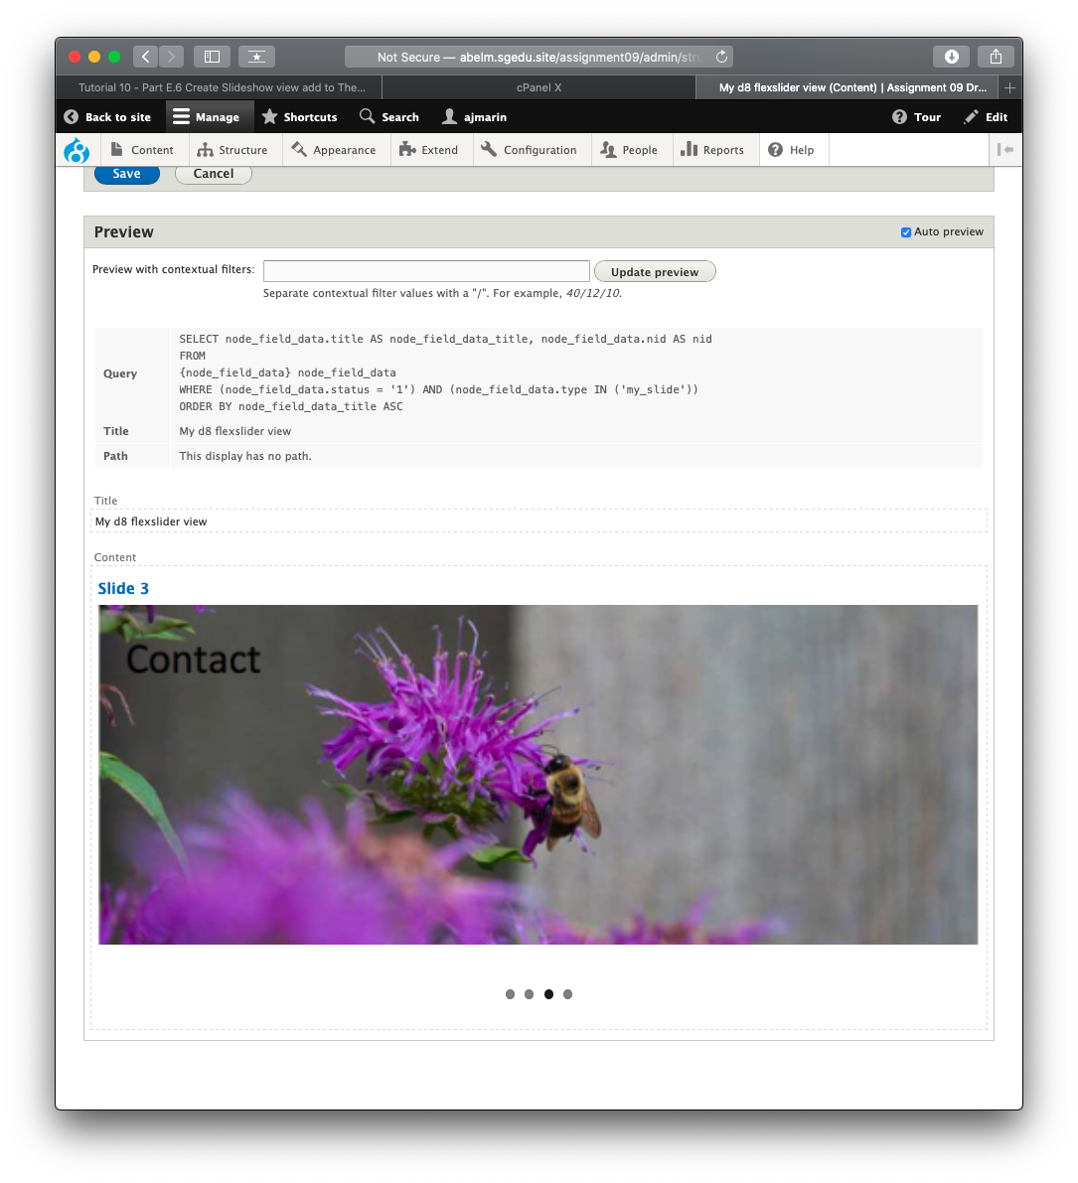] [E08.2]

1. SCREEN CAPTURE – 2 Front end screen captures showing the slideshow view – showing the first and the last slide  
   [A screenshot of a cell phone

   Description automatically generated] [E09.1]

] [E09.2]

Go back to the instructions and continue with Part F.

Part F – Updating Drupal 8 – Minor Core Update (DEMO ONLY)

1. What are the reasons you should keep your Drupal 8 website core up to date? [F01]  
   [ The main reason why you should keep you Drupal 8 website core up to date is that this is a critical way to keep your site safe from hackers. New versions of core usually patch up vulnerabilities that hackers could exploit. A catastrophic hack could result in a lot of stress a lot of time lost and potentially a lot of money lost. Another important reason is that each new update brings with it bug fixes which could range from minor inconveniences to your website being bricked. Each update brings fixes for some of these bugs. Another important reason is that there could be improvements in performance of your site. Finally, there could also be important new features with a new update. ]
2. Go back to the instructions and continue with Part G.

Part G– Updating Drupal 8 – Updating Contrib. Modules (DEMO ONLY)

1. What are the reasons you should keep your Drupal 8 website modules up to date? [G01]  
   [ The reasons for keeping your Drupal 8 modules up to date are very similar to the reason for keeping core up to date. Perhaps the most important reason is that this could keep your site safe from hackers. Updates to modules usually patch up vulnerabilities that hackers could exploit. A catastrophic hack could result in a lot of stress a lot of time lost and potentially a lot of money lost. Another important reason is that each new update brings with it bug fixes which could range from minor inconveniences to your website being bricked. Each update brings fixes for some of these bugs. Another important reason is that there could be improvements in performance of your site. Finally, there could also be important new features with a new update. ]
2. Go back to the instructions and continue with Part H.

Part H– Fixing the Trusted Host Error (DEMO ONLY)

1. According to Drupal.org what or who are Trusted Hosts?   
   What or who are we preventing or allowing access to out Drupal 8 site by fixing the Trusted Host error? [H01]  
   [ Trusted hosts are a set of regular expressions that the domains on incoming requests must match. The reason that Drupal gives for including this setting is that “It is possible to spoof the HTTP Host header for nefarious purposes, and trick Drupal into using a different domain name in several subsystems.” This means that it is possible for hackers to attack a Drupal 8 website by using a different domain other than your websites domain. Using trusted hosts eliminates this issue. ]
2. Of the 3 platforms we examined, which ones did we see the Trusted Host errors on? [H02]  
   [ Codeanywhere was the only one which had the Trusted Host error. ]
3. Which file on which folder did we modify to fix the Trusted Host errors? [H03]  
   [ We modified the settings.php which is in the default folder which itself is in the sites folder. ]